- User and Roles
---------------------------------------------------------------------------------------------------------------------------------------------------------------------------------------------------------------------
USERS TAB
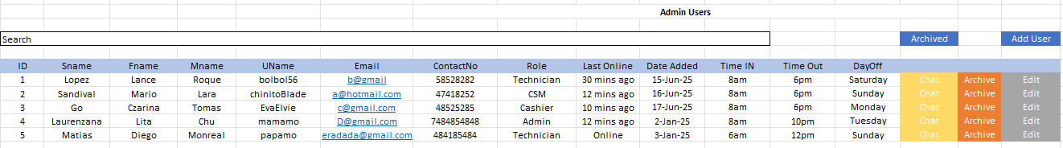
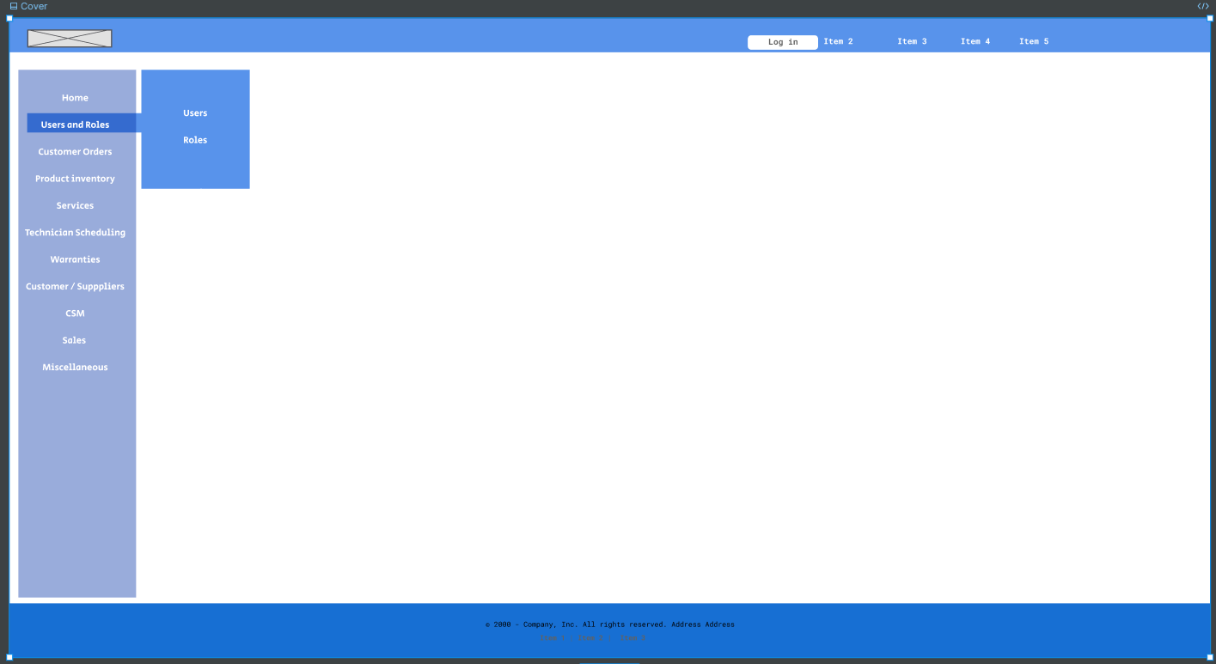
- Add User Button
  - A form will show
  - Input *Surname, *FName, *MName (Alphabet and blank space only. Check if only contains blank space, no special characters or numbers)
  - *Email (Regex), * Role (Drop Down Selection),
  - *TimeIn (Time via Clock), *TimeOut (Time via Clock), !Birthday (Date via Calendar), *Dayoff (Days via Drop Down Selection), Photo (Optional)
  - *All data must be filled else Show Snackbar and will not proceed
  - UserName (Usernames can contain letters (a-z), numbers (0-9), dashes (-), underscores (_), apostrophes ('), and periods (.)).
  - Contact Number must be unique (numeric).
  - Click Proceed Button
  - Will show form with read only (Input *Surname, *FName, *MName, *Email, * Role (Drop Down Selection), *TimeIn (Clock), *TimeOut(Clock), *Dayoff (Drop Down), Photo (Optional) if all details is correct. < Back button or save button
  - Click save button
  - If all good, Show Snackbar (new user has been added: surname, fname, role)
  - An Email and SMS will be sent to the user informing that he is enrolled in the system (Default Password will be sent to the new user)
- Chat Button
  - Upon clicking a chat box will pop on the lower rightside
  - Chat with the user
- Edit Button
  - A Form will pop showing:
  - Surname, FName, MName, Email, will be Read Only
  - TimeIn (Time via Clock ), TimeOut (Time via Clock), Dayoff (Days via Drop Down Selection), Photo (Optional) will be Editable
  - *All data must be filled else Show Snackbar and will not proceed
  - * If Technician has a repair schedule that will conflict with the new work schedule (time in, out and Dayoff), Role change and sched change will NOT proceed. Show error via Snackbar.
  - Click Save Button
  - Show Snackbar (new user has been added)
  - An Email and SMS will be sent to the user that his status has been updated (eg. “Your shift now starts @ --am to @pm, new Dayoff or role (if applicable))
- Archive Button (Per user row)
  - The Archive button temporarily deactivates a user's access, meaning their login credentials will be suspended and they will be unable to access the system.
  - *A technician with scheduled repair cannot be archive. Show Snackbar.
  - When archive button is pressed a form will pop showing:
    - Surname, FName, MName, Email, Role (Roles via Drop Down), TimeIn (Time via Clock ), TimeOut (Time via Clock), Dayoff (Days via Drop Down Selection), Photo, Last Online in READ-Only
    - Additional textfield is added as why the account will be suspended. Must not be blank
    - Within the form Click the Archive Account
  - A dialog box will show and ask if how you want to activate back the account: automatically reactivate this account or manually
    - If automatically reactivate this account, a date widget will pop (day-month-year-, hh-mm-ss) this will automatically reactivate the account, then click save
    - If manually is selected just click save
  - An Email and SMS will be sent to the user that his status has been updated (why it is suspended, time to reactivate (if applicable), or as the admin for further details)
- Archived Button
  - This will show a table containing archived users
  - Edit Button
    - A form will pop showing: Surname, FName, MName, will be read only
    - Email, Role (Roles via Drop Down), ), TimeIn (Time via Clock ), TimeOut (Time via Clock), Dayoff (Days via Drop Down Selection), can be edited, then click save to accept changes
  - Reactivate button
    - A dialog box will ask “Reactivate Surname, First Name, MiddleName, Role?” Back or Okay
    - If okay, An Email and SMS will be sent to the user informing that he is enrolled in the system (Default Password will be sent to the new user and details of the job will be included (Shift Time, Dayoff and Role))
---------------------------------------------------------------------------------------------------------------------------------------------------------------------------------------------------------------------
ROLES TAB
- Roles -this will set the kind of administrative module/s a user can control or use.
- Archive Button–
    - a Role cannot be archive if there is an active-role holder. Active Role-holders must be re-assign to other roles first. Show Snack bar the error.
    - If no active role holder, a dialog box will ask if you wanted to archive the role, < back or archive
- EDIT Button
    - A form will pop showing:
    - Role Name, Active role holder, Inactive role holder, and list of assigned modules (role names and toggle buttons)
    - If there is an active-role holders and is on their active shifts, can only add modules but not remove active module assign to the role. Active role names and toggle buttons are disable. Can only fully modify/edit this role if active-role holders are not on their shift.
    - Admin roles always have the all modules.
- Archive Roles
    - Shows list of Archived Roles
    - Reactivation (via reactivate button) of Roles is possible as long at it is bears different Role Name with the active roles. If this is true show error via snackbar.
- New Role
    - New role name must be unique, no identical name with active or archived roles to prevent confusion.
    - When creating a role, input Role Name and Toggle switches of desired modules to include, click save to finish creating the role



-----------------------------------------------------------------------------------------------------------end------------------------------------------------------------------------------------------------------

